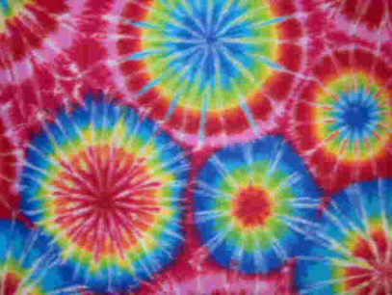
Tie Dye Chromatography

  - Materials
    - T-shirts, pillow cases, other light-colored cotton items (not your mother’s table cloth!)
    - Sharpie Markers
    - Isopropyl alcohol (91% works best but 70% will do)
    - Various sizes of beakers or other circular containers
    - Rubber Bands
    - Pipettes or droppers
  - Chemistry Concepts
    - Polarity
    - Chromatography process (stationary and mobile phases)
  - Procedure
    - Stretch part of t-shirt over the beaker opening and secure with a rubber band
    - Draw with markers a design
    - Using a pipette or dropper, drip alcohol in the center of the design fast enough that the liquid keeps moving outward but not so fast that most of it goes through the t-shirt
    - Stop dripping when the design gets to the edge of the beaker
    - Repeat all over the shirt
    - Let dry before wearing

Comments:

Use this as a wrap-up of chromatography or as an introduction to the topic. Either way kids really get into it. Young kids will enjoy the idea of it but more advanced students can look at the concepts behind chromatography and polarity.

